Day 2:-
1:- Draw a labeled diagram of an ATX motherboard and mark at least 8 different slots and ports (such as RAM slots, PCIe slots, SATA ports, USB headers, CPU socket, power connector, etc.).
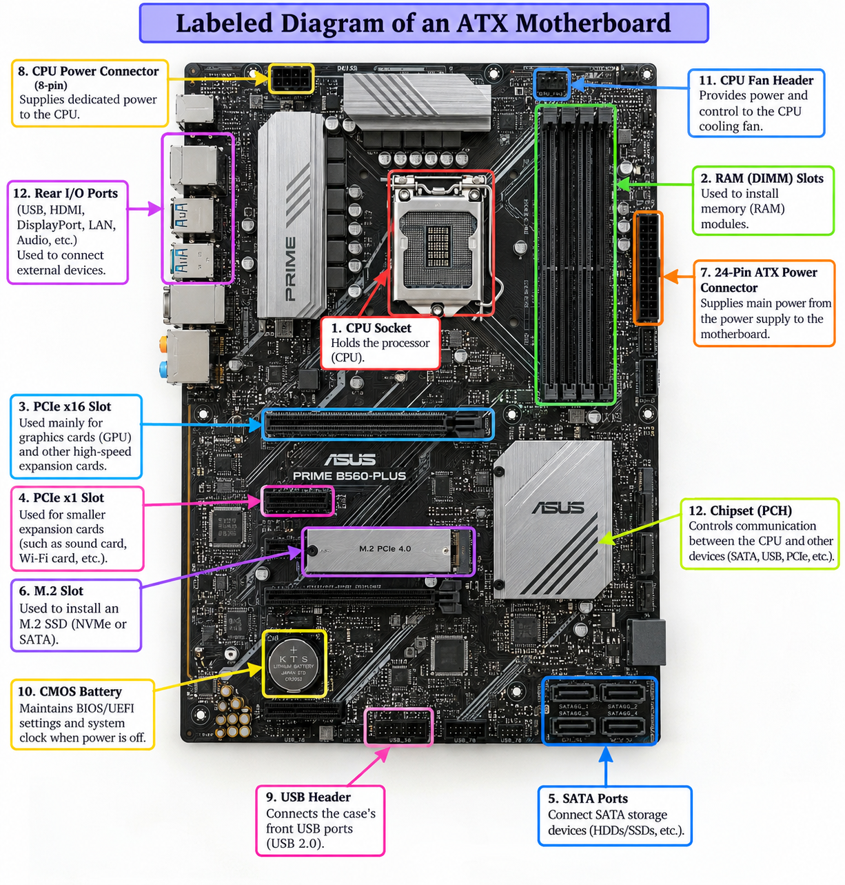

2. Identify Three Popular CPU Socket Types and Give One Compatible CPU Example for Each
A CPU socket is the physical connector on a motherboard that holds the processor and provides an electrical connection between the CPU and the motherboard. Different processors are designed for specific socket types.
CPU Socket Type | Manufacturer | Compatible CPU Example
LGA 1151 | Intel | Intel Core i7-9700
AM4 | AMD | AMD Ryzen 5 5600
LGA 1200 | Intel | Intel Core i5-10400
1. LGA 1151
LGA 1151 is an Intel CPU socket used for several generations of Intel desktop processors. One compatible processor is the Intel Core i7-9700.
Use: It provides the physical and electrical connection between the compatible Intel CPU and the motherboard.
2. AM4
AM4 is an AMD CPU socket widely used for AMD Ryzen desktop processors. One compatible processor is the AMD Ryzen 5 5600.
Use: It connects the compatible AMD processor to the motherboard and provides power and communication pathways.
3. LGA 1200
LGA 1200 is an Intel CPU socket designed for compatible 10th- and 11th-generation Intel desktop processors. One compatible processor is the Intel Core i5-10400.
Use: It securely holds the CPU and provides the electrical connection between the processor and motherboard.
Important note
LGA 1151, AM4, and LGA 1200 are socket types — i7, i5, and Ryzen 5 are processor series/tier names. The complete CPU model determines compatibility.

3. Function of CPU and Chipset
CPU – Central Processing Unit
The CPU is the main processing unit of a computer. It executes instructions, performs calculations, processes data, and controls the operations of software and other hardware components.
Main functions of the CPU:
- Executes program instructions.
- Performs calculations and logical operations.
- Processes data.
- Communicates with memory and other hardware components.
- Controls the overall operation of the computer.
Chipset
The chipset is a group of controller circuits on the motherboard that manages communication between the CPU and various hardware components. In modern computers, many functions that were traditionally handled by the chipset are integrated into the CPU, while the remaining motherboard controller is commonly called the PCH (Platform Controller Hub) on Intel systems.
Main functions of the chipset:
- Manages communication with USB devices.
- Supports storage interfaces such as SATA.
- Provides connectivity for various expansion devices.
- Helps manage communication between the processor and motherboard I/O devices.
- Provides support for features such as PCIe expansion and other motherboard connections.

How CPU and Chipset Work When Opening Spotify
When I open Spotify on a computer, the CPU and chipset work together as follows:
- I click the Spotify application.
- The operating system loads Spotify's required files from the SSD/HDD into RAM.
- The CPU executes the instructions required to start Spotify.
- The CPU communicates with RAM and storage to access the required data.
- The computer's network hardware connects to Spotify's servers through the internet.
- Spotify receives the required music data from the server.
- The CPU processes the application instructions and audio data.
- The processed audio is sent to the audio hardware, which produces sound through the speakers or headphones.
Simple flow diagram
User clicks Spotify
↓
Operating System
↓
RAM + Storage ←→ CPU
↓
Chipset / Motherboard I/O
↓
Network → Spotify Server
↓
Audio Processing
↓
Speakers / Headphones
In one sentence
The CPU performs the processing and executes Spotify's instructions, while the chipset helps manage communication between the CPU and various motherboard-connected devices such as storage, USB and other I/O components.

4.Find a clear photo of a real motherboard (from the internet or your own device), and identify at least 5 different ports or slots by circling them and labeling each one.
